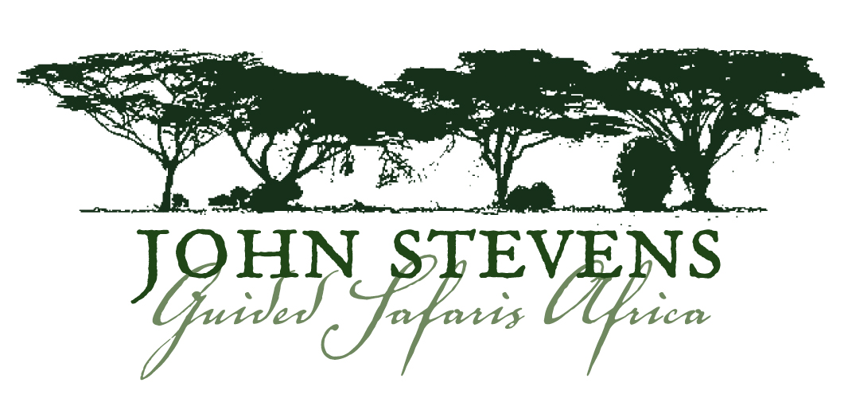

IMPORTANT LUGGAGE NOTES

This is vital information; please consider it carefully.

Please pack soft bags for your safari, not hard suitcases, as they are easier to pack in the small luggage compartments of the light aircraft that fly you from place to place and are less likely to get damaged.
A medium-sized hold-all and a daypack or small bag as hand luggage is ideal. You can use the daypack every day on your safari. Your hand luggage should include your camera equipment, toiletries, medicines and a change of underclothes.

For safety reasons these luggage restrictions are very strictly enforced.

IMPORTANT: Please note: All private charter flights are subject to weight limits that CANNOT be exceeded. If these weight limits are exceeded then the travellers will be held responsible for the extra costs incurred to upgrade the charter flight. Sometimes these flights cannot be upgraded due to all charter planes being booked - this could result in a delay in travel time and pose problems for the travellers.

THE LUGGAGE WEIGHT SHOULD NOT EXCEED 33 lbs (15 kgs) PER TRAVELLER.

WHAT TO BRING NOTES

On a wildlife safari, casual, neutral clothing is the order of the day. You will need comfortable, loose clothing that is cool, but that can be layered to keep you warm at night and in the early morning, as it can get bitterly cold at certain times of the year (May - August).

We attach a suggested packing list for your information.

Please note that formal attire is only required when staying in the more prestigious hotel establishments and even there, in Africa, “safari chic” is completely acceptable, and for ladies may be ‘dressed up’ with a simple string of beads, or a pashmina type shawl.

Safari clothing should be lightweight and in khaki tones (non reflective colours) if possible – definitely no white, light or bright-coloured clothing. Please avoid clothing resembling army uniform – “camouflage”.
Laundry is mostly hand-washed in the camps and lodges, so please avoid bringing delicate clothing.

