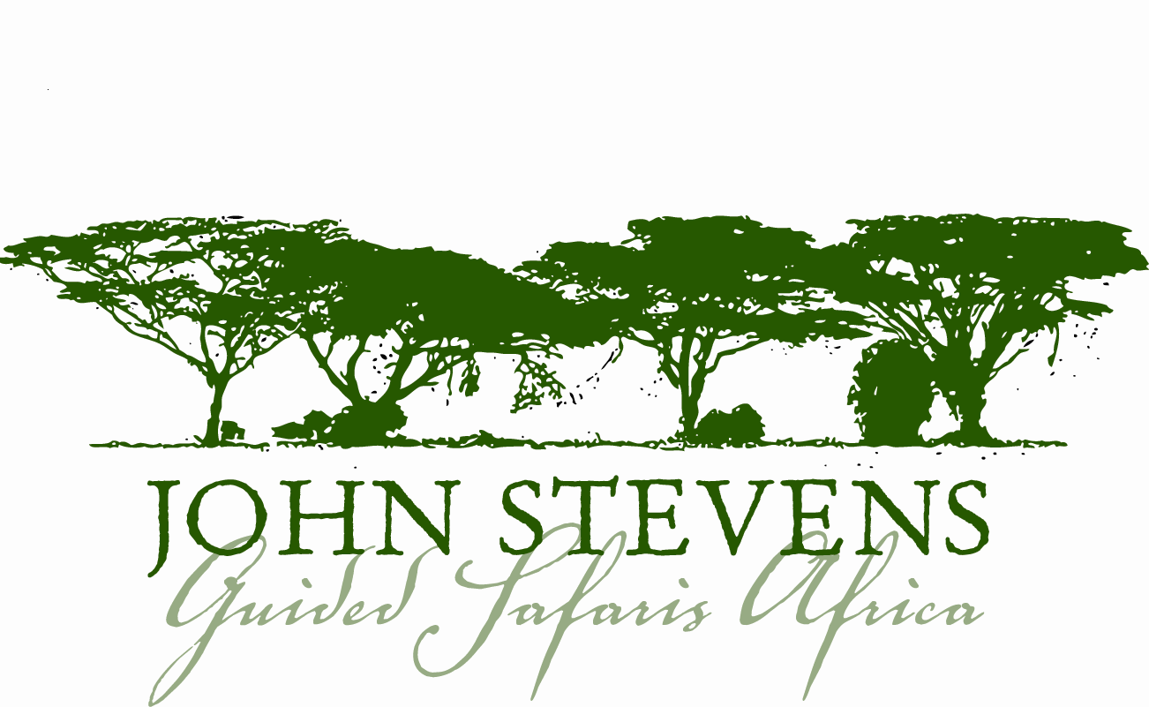

Useful Safari Information for Botswana

About Botswana

Beyond the narrow eastern corridor, where the majority of the population is concentrated, Botswana is a largely road-less wilderness of savannas, deserts, wetlands and saltpans.

Botswana is one of Africa’s real success stories. It achieved independence from Britain in 1966 and immediately thereafter discovered three of the world’s biggest diamond mines. A cosmopolitan and peaceful nation, Botswana has since benefited from social and political stability and today enjoys a truly non-racial democratic government with good health, education and economic standards.

Time: Botswana is 2 hours ahead of Greenwich Mean Time. For an accurate calculation please visit http:// www.timeanddate.com/worldclock and search for Gaborone/Botswana.

Communications: Botswana enjoys good telephone and email communications but camps and lodges generally do not have cell phone coverage. They do have radio communications. In your final safari itinerary we will try to advise exactly what communication each camp or lodge you are using will have. John Stevens carries a satellite phone for emergency use only.

Voltage: Voltage in Botswana is 220V-260V, 50Hz. If you bring appliances please remember to bring a universal adapter.

Language: English is spoken widely; the national language is Setswana.

Politics: Botswana is a multiparty democracy, enjoying a stable, non-racial and peaceful political environment.

Climate: Although it straddles the Tropic of Capricorn, Botswana experiences extremes in temperature. Days are normally clear, warm and sunny, but nights range from cool to bitterly cold. In the Kalahari, it is normal for nighttime temperatures to fall to subfreezing in June and July and where there is enough moisture, frosts are common. Botswana is primarily a dry country, but the rainy season lasts roughly from November to March. From late May to August, rain is rare anywhere in the country.

Seasons:
Spring (October to November) hot, dry days and hot nights.

Summer (November to March) long, very hot days and short nights with periodic rain and thunderstorms.

Autumn (April to May) hot days and cooler to cold nights.

Winter (June to August) cold dry and windy days with very cold nights

Currency: The unit of currency is Botswana Pula, which is divided into 100 cents. There are no restrictions on the movement of currency into or out of Botswana.

Before your Trip

Entering and Exiting Botswana

A valid passport is required for entry into Botswana.

No visa is required for visits of up to 90 days for citizens of most Commonwealth countries, most European countries and the USA. As visa requirements change from time to time please check with your nearest Botswana Embassy or Consulate well in advance. Residents of the following countries may consult these websites for up-to-date information:

USA: www.travel.state.gov Of special interest is the section “Consular Information Sheets.”
Australia: www.smarttraveller.gov.au
UK: www.fco.gov.uk
Canada: www.voyage.gc.ca

Passengers must hold a return/onward ticket and sufficient funds.
Any departure taxes should be included on your ticket.

Health Requirements and Recommendations

Malaria is endemic to Botswana and malaria protection is essential. Please remember that the best protection against malaria is not to get bitten, so mosquito repellent is advised for the early morning and evenings when mosquitoes are at their most active. Long trousers, socks and long-sleeved shirts are advisable in the evening. Do not forget to take the tablets prescribed both before arrival and for the specified length of time on your return. This latter information is especially important. For up-to-date and appropriate information on malaria in Botswana and for the correct medication to take, please consult: http://www.who.int/ith/en/ or your local doctor. On the WHO site, there is a special section devoted to malaria, indicating in which areas the disease is resistant to certain types of prophylaxis.

Please bring your own supply, as many of these prophylactics are often in short supply and difficult to get whilst on safari. Please consult your own doctor, specialist centre for tropical diseases, or the above noted website for up to date information on a variety of medications to prevent malaria and other tropical diseases in Botswana.

If you are on any medication please bring sufficient supplies with you and inform us of any medical conditions that you may suffer that may trouble you during your trip. In order to record any important medical information, we will be sending you a pre-safari questionnaire just prior to your safari.

Insurance: Travel, Property and Medical

Anyone coming on safari with John Stevens Guided Safaris Africa must obtain his or her own comprehensive holiday and medical insurance. While we take every care of you and your property, we cannot be held responsible for any accidents, injury, or illness that may incur or for loss or damage to baggage. We therefore advise that you and your property be fully covered by insurance and it is advisable to have separate baggage and ticket insurance. We strongly recommend Trip Cancellation insurance.

As part of our pre-safari questionnaire mentioned above we will be asking you to give us your medical policy number and emergency contact details.

Special Requirements

On the pre-safari questionnaire we will be asking you to send us any special requirements you may have, dietary or otherwise, so that we can do our best to accommodate them. When doing a mobile safari it is vital to give us this information early as only a limited amount of stock can be carried.

Money

Most of the camps and lodges we visit are on a full board basis, and as park fees are included in the price of your safari, unless otherwise stated, you will only need money for extras such as some drinks, tips, extra excursions and personal purchases. For general currency information, we suggest you consult the following site: www.xe.com

Botswana Pula can be obtained on arrival at the airport. We advise that you only change a small amount of money. US dollars are generally acceptable (much more so than Sterling and Euros). Large denominations may be difficult to use so we advise you bring a selection of smaller notes. Please consider a ‘money belt’ as a useful, lightweight accessory in which to safely store your money and passport.

Banks accept travellers cheques and most major credit cards. Hotels and lodges accept travellers cheques but only some credit cards, e.g. Visa and MasterCard. Credit cards and travellers cheques will attract bank charges so wherever possible cash is recommended.

Tipping

Tipping is traditionally offered if you are happy with the service and is always enthusiastically received. As a general rule of thumb, around $10 per person per day would be shared amongst all the camp staff. Driver/guides could be tipped separately, at about $15 - $20, from the group.

Gifts

We do our best to have as little impact as possible on the local culture. Furthermore, the best of intentions can unfortunately teach children the demeaning benefits of begging. As a result, we generally advise against giving gifts randomly. If you do want to make a contribution then basic educational items are best, but again these are better presented to local schools or elders for appropriate use. We can arrange this for you. Please visit our community page, for more ideas on community support/involvement - http://www.johnstevenssafaris.com/community.php

Reference Books

The camps will have an array of up-to-date reference books on animals, birds, and trees. You may have an absolute favourite, or an up-to-the minute iPod with birdcalls, which you cannot live without. Please remember the luggage weight of 10 kg and bring only the most essential.

