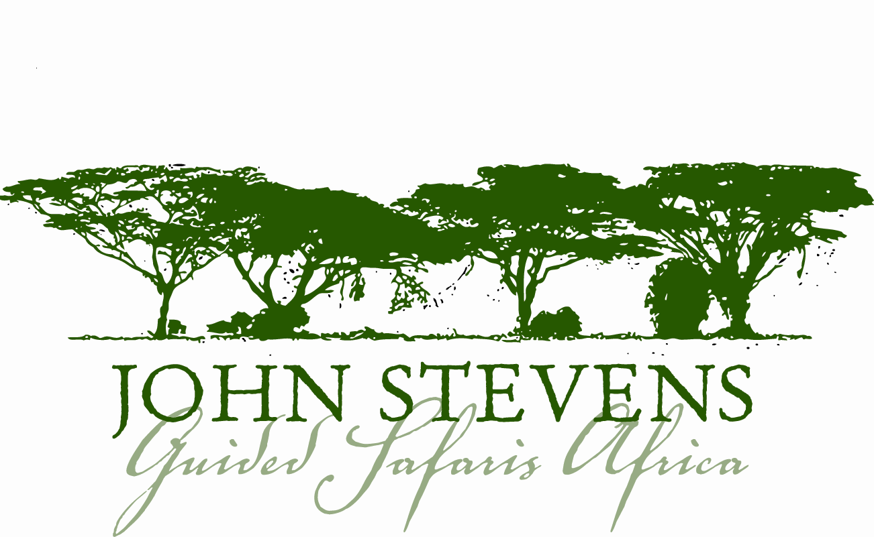

Useful Safari Information for Mozambique

About Mozambique

Mozambique is one of Africa’s up-and-coming hot-spots, with stunning beaches, excellent diving and magical offshore islands. Go snorkelling around the Bazaruto Archipelago, sail on a dhow through mangrove channels or laze under the palms in the Quirimbas Archipelago, take an off-beat safari in the wilds of Gorongosa National Park, wander along cobbled streets past stately colonial-era buildings on Ilha de Moçambique, sip a café espresso at one of Maputo’s lively sidewalk cafés (or maybe a caipirinha at one of its jazz bars), watch the silversmiths at work on Ibo Island or dance to the country’s trademark marrabenta music.

Politics: These follow the framework of a presidential representative democratic republic, whereby the President is head of state and head of government of a multi-party system. Executive power is exercised by the government. Armando Guebuza of the FRELIMO party was inaugurated as the President of Mozambique in 2005.

Time: Mozambique is GMT plus 2 hours, there is no daylight saving. For an accurate calculation please visit http://www.timeanddate.com/worldclock and search for Mozambique.

Communications: Mozambique enjoys acceptable cellular communications. Camps and lodges have radio communications with their main office, which normally has a landline or satellite phone.

Voltage: Voltage in Zambia is 220 volts. Plugs are 2 pin or 3 pin round. If you bring appliances please remember to bring a universal adapter.

Language: The official language of Mozambique is Portuguese, plus several indigenous Bantu dialects.

Climate: Sunshine, blue skies and temperatures averaging between 24°C and 27°C along the coast are the norm, except during the rainy summer season from about December/January through to April when everything gets soggy and sticky, and temperatures exceed 30°C in some areas.
The best time to visit is from May/June to November, during the cooler dry season. During the Christmas/New Years holidays, around Easter and in August, the southern resorts fill up with the vacationing South African neighbours.

Currency: Mozambique’s currency is the metical (plural – meticais). As of mid-2006, the ‘metical nova família’ (new family metical) was introduced, at a rate of 1000 old meticais to one new metical.

All major towns have ATMs, often operated by Banco Internacional de Moçambique (BIM), and all accepting Visa, but not MasterCard.

You can change US dollars cash at most banks (though not at most BIM branches) without paying commission, and South African rands are widely accepted in southern Mozambique. Travellers cheques can be changed only at Standard Bank (minimum US$35 commission per transaction, original purchase receipt required).

Before your Trip

Entering and Exiting Mozambique

International travellers require a visa for Mozambique, which is purchased on arrival in Mozambique and paid for in US$ cash - currently US$85 and could be subject to change.
An additional US$2.50 stamp duty applies for entrance and exit, so we advise clients should be in possession of US$90 cash in small denominations.
South African passport holders do not require a visa to enter Mozambique. South African Passports need to have a 1 month validity from date of entrance in Mozambique.
Please contact the Mozambique High Commission if you are unsure. For entrance back into South Africa, two empty pages are needed in passports (front and back pages both blank).
*Clients travelling to Inhambane will purchase their visas in ZAR – currently R250 per person.

The following may be useful sources of information for residents of these countries…

USA: www.travel.state.gov Of special interest is the section “Consular Information Sheets.”
Australia: www.smarttraveller.gov.au
UK: www.fco.gov.uk
Canada: www.voyage.gc.ca

Additional Money To Be Paid At The Various Airports

Pemba: Immigration tax of US$6.00 per person to be paid on arrival/departure from Pemba Airport Vilanculos: Immigration tax of US$6.00 per person to be paid on arrival/departure from Vilanculos Airport Inhambane: R17 per person will need to be paid on departure from Inhambane Airport

Health Requirements and Recommendations

Malaria is endemic to most parts of Mozambique, and malaria protection is essential. Please remember that the best protection against malaria is not to get bitten, so mosquito repellent is advised for the early morning and evenings when mosquitoes are at their most active. Long trousers, socks and long-sleeved shirts are advisable in the evening. Do not forget to take the tablets prescribed both before arrival and for the specified length of time on your return. For up to date and appropriate information on malaria in Mozambique and for the appropriate medication to take, please consult: http://www.who.int/ith/en/ where there is a special section devoted to malaria.

All visitors to Mozambique are advised to take anti-malarial tablets beginning one week before arrival and continuing for at least four weeks after departure. Please bring your own supply, as many of these prophylactics are often in short supply and difficult to get whilst on safari. Please consult your own doctor, specialist centre for tropical diseases, or the above noted website for up to date information on a variety of medications to prevent malaria and other tropical diseases in Mozambique.

If you are on any medication, please bring sufficient supplies with you and inform us of any medical conditions that you suffer from that may trouble you during your trip. In order to record any important medical information, we will be sending you a pre-safari questionnaire just prior to your safari.

Insurance: Travel, Property and Medical

Anyone coming on safari with John Stevens Guided Safaris Africa must obtain his or her own comprehensive holiday and medical insurance. While we take every care of you and your property, we cannot be held responsible for any accidents, injury, or illness that may occur or for loss or damage to baggage. We therefore advise that you and your property be fully covered by insurance and it is advisable to have separate baggage and ticket insurance. We strongly recommend Trip Cancellation insurance.

As part of our pre-safari questionnaire mentioned above we will be asking you to give us your medical policy number and emergency contact details.

Special Requirements

On the pre-safari questionnaire we will be asking you to send us any special requirements you may have, dietary or otherwise, so that we can do our best to accommodate them.

Money

Most of the resorts and lodges are on a full board basis, and unless otherwise stated, you will only need money for extras such as some drinks, tips, extra excursions and personal purchases.

Please consider a ‘money belt’ as a useful, lightweight accessory in which to safely store your money and passport.

Tipping

Tipping is traditionally offered if you are happy with the service and is always enthusiastically received. As a very general rule of thumb, around $5 - $10 per person per day would be shared amongst all the camp staff. Driver/guides can be tipped separately, at about $15 - $20, from the group. South African Rands are an acceptable equivalent.

Gifts

We do our best to have as little impact as possible on the local culture. Furthermore, the best of intentions can unfortunately teach children the demeaning benefits of begging. As a result we generally advise against giving gifts randomly. If you do want to make a contribution then basic educational items are best, but again these are better presented to local schools or elders for appropriate use. We can arrange this for you. Please visit our community page, for more ideas on community support/involvement - http://www.johnstevenssafaris.com/community.php

