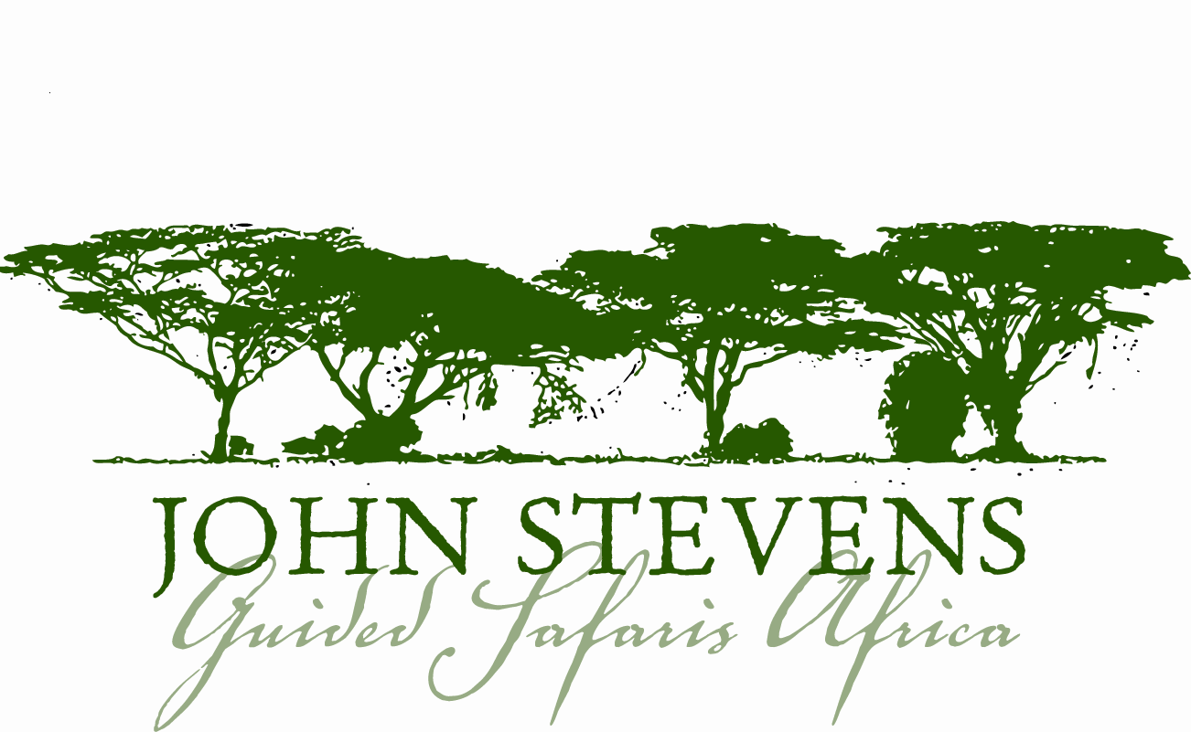

Useful Safari Information for Zimbabwe

About Zimbabwe

Ever since Livingstone brought the good news from the heart of Africa 140 years ago, people have yearned to see the enchanting country of the Victoria Falls - Zimbabwe. The wonders of the landscape are matched by a variety and density of wildlife comparable with the world’s best, and the country has no fewer than four World Heritage Sites, as registered by UNESCO; the famous Victoria Falls, beautiful and bountiful Mana Pools National Park, Matobo Hills and the great medieval African cities of Khami and Great Zimbabwe.

Time: Zimbabwe is GMT plus 2 hours, there is no daylight saving. For an accurate calculation please visit http://www.timeanddate.com/worldclock and search for Harare, Zimbabwe.

Communications: Zimbabwe currently enjoys acceptable telephone and email communications. Camps and lodges have radio communications with their main office, which normally has a landline or satellite phone.

Voltage: Voltage in Zimbabwe is 240 volts. Plugs are square pin. If you bring appliances please remember to bring a universal adapter.

Language: English is spoken widely; the most prevalent national language is Shona.

Politics: Zimbabwe is a Republic, with a parliamentary system of Government. It has been ruled since independence in 1980 by Robert Mugabe of the ZANU-PF party. In late 2008 Mugabe agreed to share power with Morgan Tsvangirai of the Movement for Democratic Change. Tsvangirai became Prime Minister and Robert Mugabe Head of State and Commander in Chief of the Armed Forces.

Climate: Along with much of southern Africa, Zimbabwe's altitude means a temperate climate. It is considered by many to be ideal, with perfect sunny blue skies during the day and agreeable nights, prompting the wags to note - “APDIA’ Another Perfect Day In Africa”

Seasons:
April/May Warm/Hot, still potential rain storms around.
June/July Cool/warm during the day.
Mid winter - can be very cold at night/early morning.
August Varied from cool (not cold) to hot.
September/October Hot and dry.
Occasional thunderstorms in October.
November/December Hot, humid.
Early rains vary from the odd shower to daily rainfall.
December/April Warm weather, but it is the Rainy Season; may rain for only part of the day, or all day for several days at a time

Currency: The revised unit of currency in Zimbabwe is the United States Dollar (USD $). All hotels, lodges & resorts accept payment in US $ either in cash and/or where possible (technology & equipment permitting) with a Debit or Credit card. Exchanging monies may be done through normal banking means i.e. converting currencies and payments alike. Cash, however, is short in Zimbabwe so we strongly recommend that you try by all means and as securely as possible, to bring cash with you, preferably in small notes as change is a problem due to the shortage of hard cash. Do not be tempted into changing any monies of any sort or value with any other person, business or institute other than official banking facilities and bureau de change offices.

Before your Trip

Entering and Exiting Zimbabwe

A valid passport and visa is required for entry into Zimbabwe.

Please check with the Embassy of Zimbabwe or consult the websites listed below for the most up-to-date information concerning visa requirements for travellers from various countries.

USA: www.travel.state.gov Of special interest is the section “Consular Information Sheets.”
Australia: www.smarttraveller.gov.au
UK: www.fco.gov.uk
Canada: www.voyage.gc.ca

Passengers must hold a return/onward ticket and sufficient funds for their stay in the country. Any departure taxes should be included on your ticket. Internal flights entail a departure tax of USD 10, for both the domestic airline and for charter flights,

Health Requirements and Recommendations

Malaria is endemic to most parts of Zimbabwe except Harare, and malaria protection is essential. Please remember that the best protection against malaria is not to get bitten, so mosquito repellent is advised for the early morning and evenings when mosquitoes are at their most active. Long trousers, socks and long-sleeved shirts are advisable in the evening. Do not forget to take the tablets prescribed both before arrival and for the specified length of time on your return. For up to date and appropriate information on malaria in Zimbabwe and for the appropriate medication to take, please consult: http://www.who.int/ith/en/ where there is a special section devoted to malaria.

All visitors to Zimbabwe are advised to take anti-malarial tablets beginning one week before arrival and continuing for at least four weeks after departure. Please bring your own supply, as many of these prophylactics are often in short supply and difficult to get whilst on safari. Please consult your own doctor, specialist centre for tropical diseases, or the above noted website for up to date information on a variety of medications to prevent malaria and other tropical diseases in Zimbabwe.

Travellers are required to carry evidence of a yellow fever vaccination if they are arriving in Zimbabwe from infected areas.

If you are on any medication, please bring sufficient supplies with you and inform us of any medical conditions that you suffer from that may trouble you during your trip. In order to record any important medical information, we will be sending you a pre-safari questionnaire just prior to your safari.

Insurance: Travel, Property and Medical

Anyone coming on safari with John Stevens Guided Safaris Africa must obtain his or her own comprehensive holiday and medical insurance. While we take every care of you and your property, we cannot be held responsible for any accidents, injury, or illness that may occur or for loss or damage to baggage. We therefore advise that you and your property be fully covered by insurance and it is advisable to have separate baggage and ticket insurance. We strongly recommend Trip Cancellation insurance.

As part of our pre-safari questionnaire mentioned above we will be asking you to give us your medical policy number and emergency contact details.

Special Requirements

On the pre-safari questionnaire we will be asking you to send us any special requirements you may have, dietary or otherwise, so that we can do our best to accommodate them. When doing a mobile safari it is vital to give us this information as only a limited amount of stock can be carried.

Money

Most of the camps and lodges we visit are on a full board basis, and as park fees are included in the price of your safari, unless otherwise stated, you will only need money for extras such as some drinks, tips, extra excursions and personal purchases.

Zimbabwe uses the US Dollar. We advise you bring a selection of the smaller notes, as large denominations may be difficult to use. Make sure you have notes issued after 2000 as for some reason older notes are often not accepted. Please consider a ‘money belt’ as a useful, lightweight accessory in which to safely store your money and passport.

Banks accept travellers cheques and most major credit cards. Most hotels and lodges accept travellers cheques but only some credit cards, e.g. Visa, American Express and MasterCard. Amanzi Lodge will not accept credit cards only cash or travellers cheques (for extras).

Credit cards and travellers cheques will attract bank charges so, wherever possible, cash is recommended.

Tipping

Tipping is traditionally offered if you are happy with the service and is always enthusiastically received. As a very general rule of thumb, around $5 - $10 per person per day would be shared amongst all the camp staff. Driver/guides can be tipped separately, at about $15 - $20, from the group.

Gifts

We do our best to have as little impact as possible on the local culture. Furthermore, the best of intentions can unfortunately teach children the demeaning benefits of begging. As a result we generally advise against giving gifts randomly. If you do want to make a contribution then basic educational items are best, but again these are better presented to local schools or elders for appropriate use. We can arrange this for you. Please visit our community page, for more ideas on community support/involvement - http://www.johnstevenssafaris.com/community.php

Reference Books

The camps will have an array of up-to-date reference books on animals, birds, and trees. You may have an absolute favourite, or an up-to-the minute iPod with birdcalls, which you cannot live without. Please remember the luggage weight of 10 kg and bring only the most essential.

