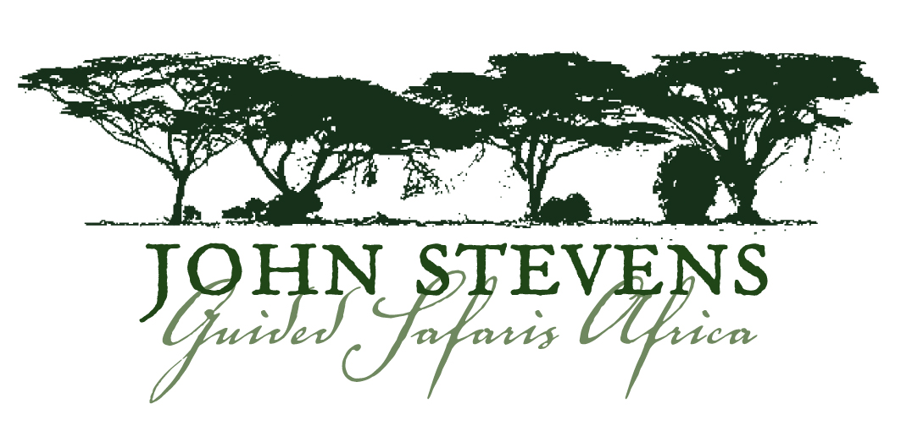

Suggested Packing List

These suggestions are a guide only. Do bear in mind that your luggage weight, inclusive of clothing and miscellaneous items, should not exceed 33 lbs or 15kgs per traveller. N.B. Clothing: Stick to neutral colours. Khaki, light brown/green, tan. Avoid bright colours & white for improved game viewing, especially when on foot. Not as important in a vehicle.

CLOTHES

Khaki casual clothing for safari (2/3 changes)
2 pairs of shorts
2 T-shirts/short sleeved cotton shirts
1 pair of long trousers/light jeans/convertible pants – with zips
1 long-sleeved cotton shirt
1 fleece jacket/jersey
1 waterproof jacket/windbreaker
1 good safari hat - Try the Tilley Aussie-Style T3 Hat.
Orvis also has a selection of safari hats for women and men to choose from.
John wears a Columbia Omni-Shade. http://www.columbia.com/Omni- Shade%E2%84%A2-Bora-Bora%E2%84%A2-Booney/CU9745,default,pd.html#
Gloves/mittens/scarf for colder months of June – August, Southern Africa
Bandana to wet and tie around your neck in extreme heat – October, Southern Africa
A ‘pashmina’ or similar shawl – for added winter warmth or to smarten up an evening outfit.
5 pairs socks – microfibre recommended
1 sleeveless safari-style flack jacket with handy pockets - optional

Casual clothes for camp/lodge (2 changes)
1 casual long trousers
1 golf shirt
1 casual long-sleeved shirt and/or 1 blouse
1 dress
1 sarong
1 swimming costume/bathing suit

Underwear
5 changes of underwear.
(Note for ladies: bring a sports bra for game drives on bumpy, uneven roads)

SHOES
1 pair good walking shoes/cross trainers – “worn-in”
1 pair of sandals or flip-flops/thongs

MISCELLANEOUS/ESSENTIALS
Sunglasses – preferably polarized and on a string. Sunglasses case comes in handy.
Camera and lenses, lens cleaner, plus extra batteries and memory cards.
Plug adaptors – generally, plugs in Africa are 3-prong square or round.
Binoculars – 1 pair per person recommended. You will be very disappointed if you do not have a good pair of binoculars. Nikon or Minolta make fine, lightweight viewing binoculars. Try general game viewing 7 X 28, or 8 X 20 binoculars.
John uses Zeiss Victory FL 8 x 32T. http://www.zeiss.com/C12568CF00206298/ContainerTitel/FL_Landing/$File/index.html
Flashlight/Torch and Headlamp, plus extra batteries – per person.
Basic medical kit: Band-Aids, antiseptic cream, 1 course of antibiotics, Tylenol/Advil, laxative, anti-diarrheal medication, eye drops, anti-histamine cream, tweezers, nail scissors. (There are first aid kits in all camps and lodges)
Prescribed medicine (with copy of prescription)
Anti-malaria tablets
Insect repellant – small bottle of Deet, Tabbard, Rid, for example. (The camps usually have spray in rooms)
If you wear contact lenses, bring along a pair of spectacles, too. Sand and dust are hard on the eyes.
Sunblock with a high SPF and Aftersun lotion.
Personal toiletries: small shampoo, shaving cream, skin and hair moisturisers, lip balm, sanitary requirements, etc. It is recommended that moisturisers, deodorants, etc are non-scented, so as not to attract insects. Most camps and lodges supply small quantities of soap and shampoo.
Small packet/tube of laundry soap for hand washing ladies’ lingerie. It is customary for women guests to hand-wash their own.
Tissues/”Wet Ones”/Small bottle antibacterial hand gel – handy in airports and in the safari vehicle.
Photocopies of your passport, visas, credit card numbers and airline tickets (to be kept separately)
Variety of plastic zip-lock bags, to store wet items or protect equipment/store shoes, etc.
Travel alarm clock
Day backpack (small) – for use in the vehicle and on walks.
A ‘money belt’ as a useful, lightweight accessory in which to safely store your money and passport and to keep them with you at all times.
Reference/Field guides and Bird books - optional

DOCUMENTS
Valid passport with visas
Emergency phone numbers
Insurance documentation
Vaccination Certificates

